Hosted Payment Page
# Source: AI Source: Provided by: [Data Path: Persons Table -> ID Column: 1, Name_En Column: Motasem Essam] -> From: [ChatGPT] on [1/21/2026]
A Hosted Payment Page (HPP) is a secure, external checkout page provided by a payment gateway where customers are redirected to complete their payment. It's the simplest and safest way to accept online payments without handling sensitive card data directly on your own server.

🧠 Simple Definition
# Source: AI Source: Provided by: [Data Path: Persons Table -> ID Column: 1, Name_En Column: Motasem Essam] -> From: [ChatGPT] on [1/21/2026]
A Hosted Page is a payment form hosted by the gateway, not by your website — so you redirect the user to their domain to complete the payment.

🛠️ How It Works
# Source: AI Source: Provided by: [Data Path: Persons Table -> ID Column: 1, Name_En Column: Motasem Essam] -> From: [ChatGPT] on [1/21/2026]
- On your site, the customer clicks “Pay”.
- Your app creates a payment session via the gateway’s API.
- The user is redirected to the gateway’s secure page (e.g., https://pay.gateway.com/checkout/xyz).
- The customer enters card/wallet/OTP info on that page.
- Upon success or failure, the gateway redirects the user back to your website with the result.

🔐 Why Use a Hosted Page?
# Source: AI Source: Provided by: [Data Path: Persons Table -> ID Column: 1, Name_En Column: Motasem Essam] -> From: [ChatGPT] on [1/21/2026]
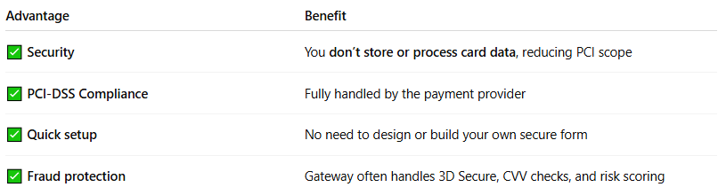

Advantage | Benefit
✅ Security | You don’t store or process card data, reducing PCI scope
✅ PCI-DSS Compliance | Fully handled by the payment provider
✅ Quick setup | No need to design or build your own secure form
✅ Fraud protection | Gateway often handles 3D Secure, CVV checks, and risk scoring

💳 Example Use Cases
# Source: AI Source: Provided by: [Data Path: Persons Table -> ID Column: 1, Name_En Column: Motasem Essam] -> From: [ChatGPT] on [1/21/2026]
- E-commerce checkout (redirect to Paymob or FawryPay)
- Charity or donation forms
- Event ticketing sites
- SaaS apps with one-time or subscription payments

🧪 Example Flow
# Source: AI Source: Provided by: [Data Path: Persons Table -> ID Column: 1, Name_En Column: Motasem Essam] -> From: [ChatGPT] on [1/21/2026]
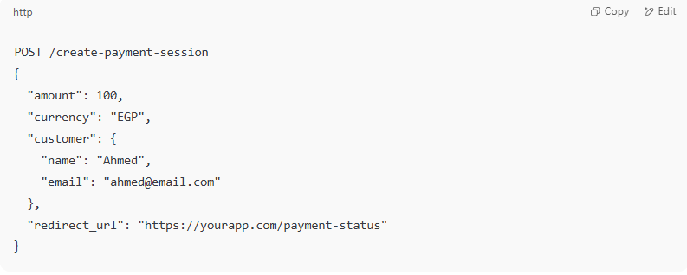

- Your backend calls:
POST /create-payment-session
{
"amount": 100,
"currency": "EGP",
"customer": {
"name": "Ahmed",
"email": "ahmed@email.com"
},
"redirect_url": "https://yourapp.com/payment-status"
}

- Gateway returns a link like:
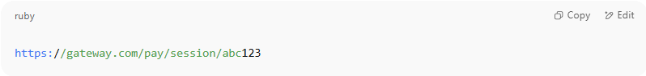
https://gateway.com/pay/session/abc123

- Redirect the customer to that page.
- After payment, they are redirected back to your app.

❗ Potential Limitations
# Source: AI Source: Provided by: [Data Path: Persons Table -> ID Column: 1, Name_En Column: Motasem Essam] -> From: [ChatGPT] on [1/21/2026]
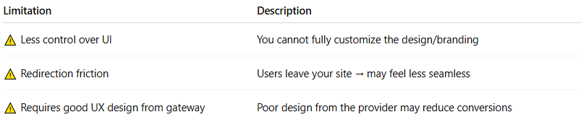

Limitation | Description
⚠️ Less control over UI | You cannot fully customize the design/branding
⚠️ Redirection friction | Users leave your site → may feel less seamless
⚠️ Requires good UX design from gateway | Poor design from the provider may reduce conversions

🔍 Hosted Page vs. Embedded Form
# Source: AI Source: Provided by: [Data Path: Persons Table -> ID Column: 1, Name_En Column: Motasem Essam] -> From: [ChatGPT] on [1/21/2026]
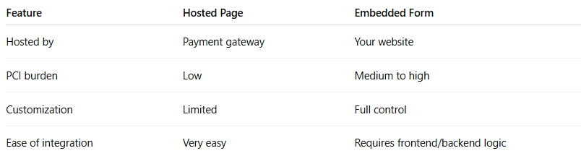

Feature | Hosted Page | Embedded Form
Hosted by | Payment gateway | Your website
PCI burden | Low | Medium to high
Customization | Limited | Full control
Ease of integration | Very easy | Requires frontend/backend logic

🧠 Summary
# Source: AI Source: Provided by: [Data Path: Persons Table -> ID Column: 1, Name_En Column: Motasem Essam] -> From: [ChatGPT] on [1/21/2026]
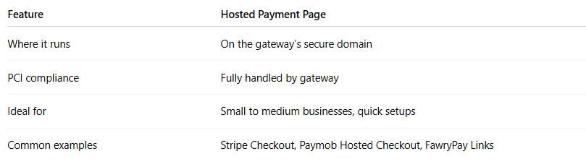

Feature | Hosted Payment Page
Where it runs | On the gateway’s secure domain
PCI compliance | Fully handled by gateway
Ideal for | Small to medium businesses, quick setups
Common examples | Stripe Checkout, Paymob Hosted Checkout, FawryPay Links

